
National Textile University
Department of Computer Science
Subject:
MAD

Submitted to:
Sir Rehan Sarwar

Submitted by:
Asbah Asif

Reg number:
23-NTU-CS-1141

Lab:
04

Semester:
6th

Phase: 1 & 2
Code:
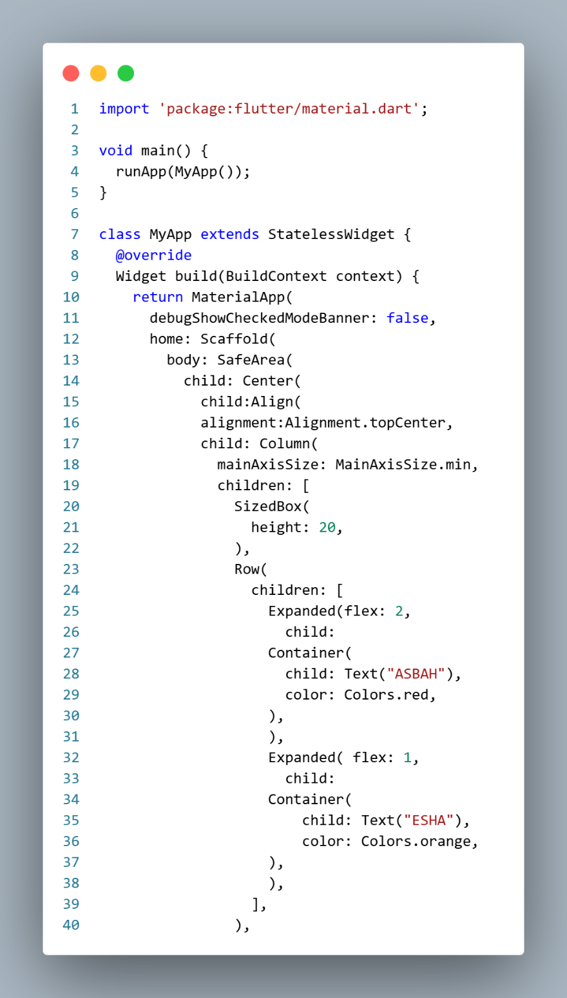

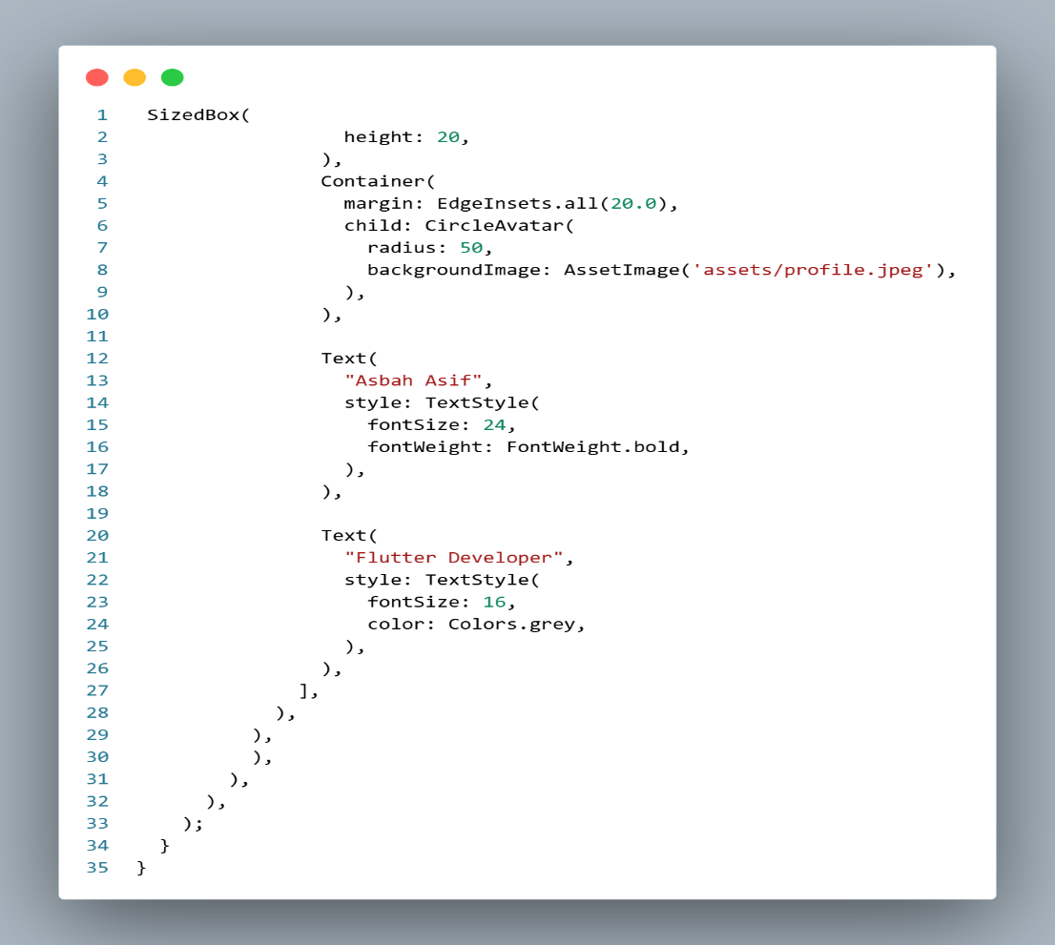

Output:
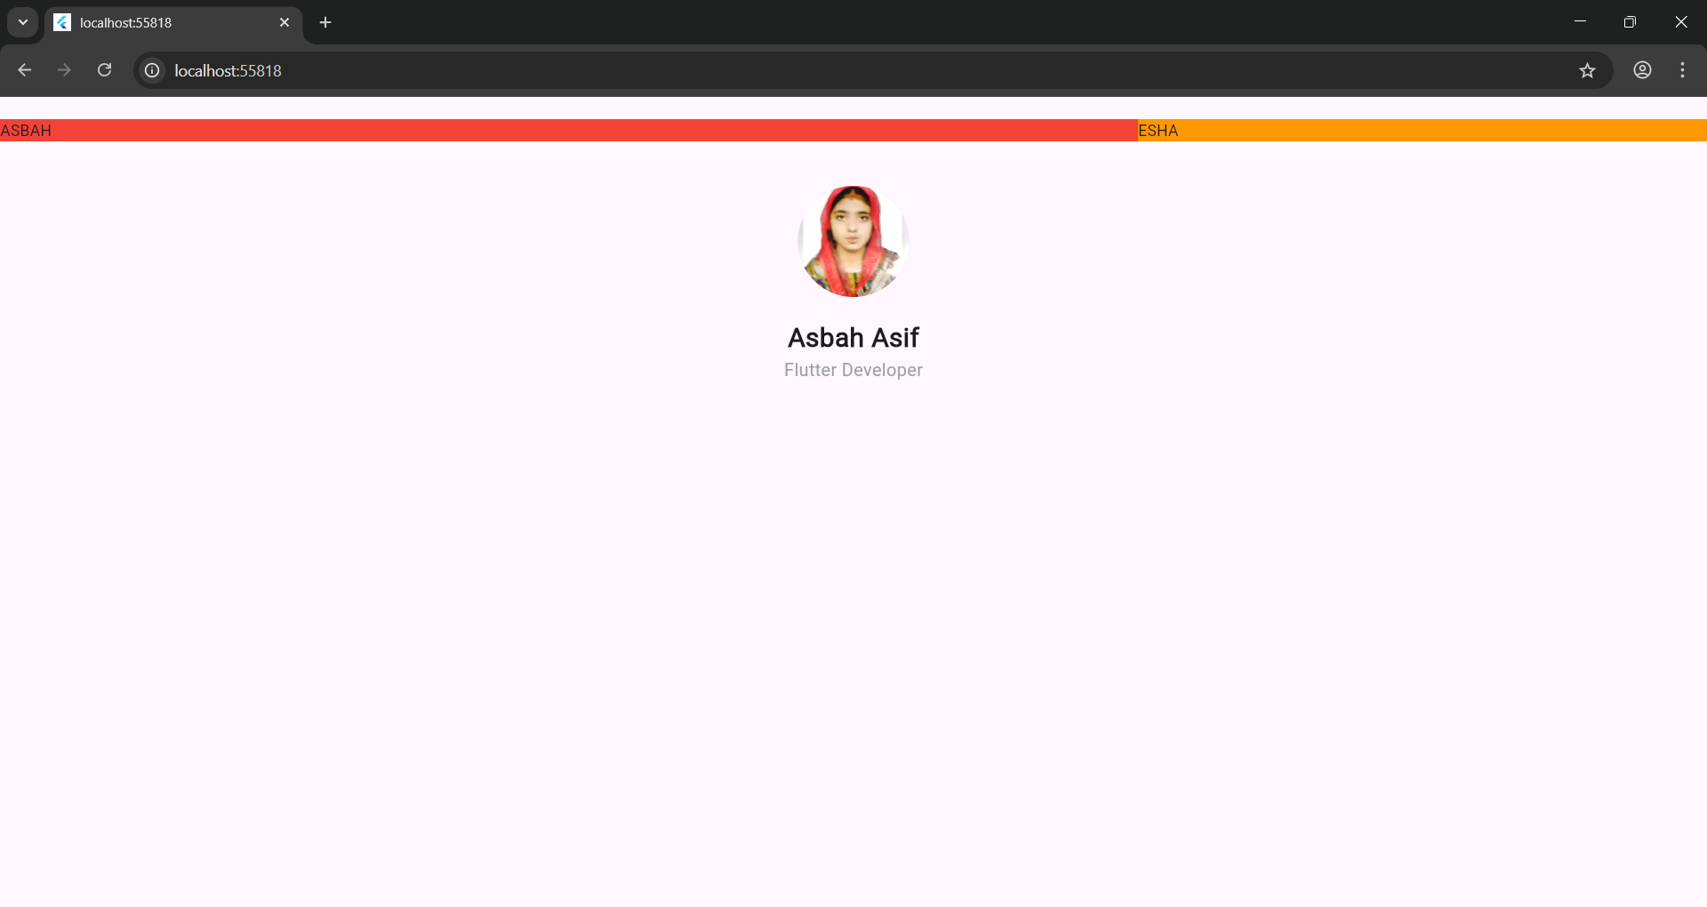
Phase: 3
Code:
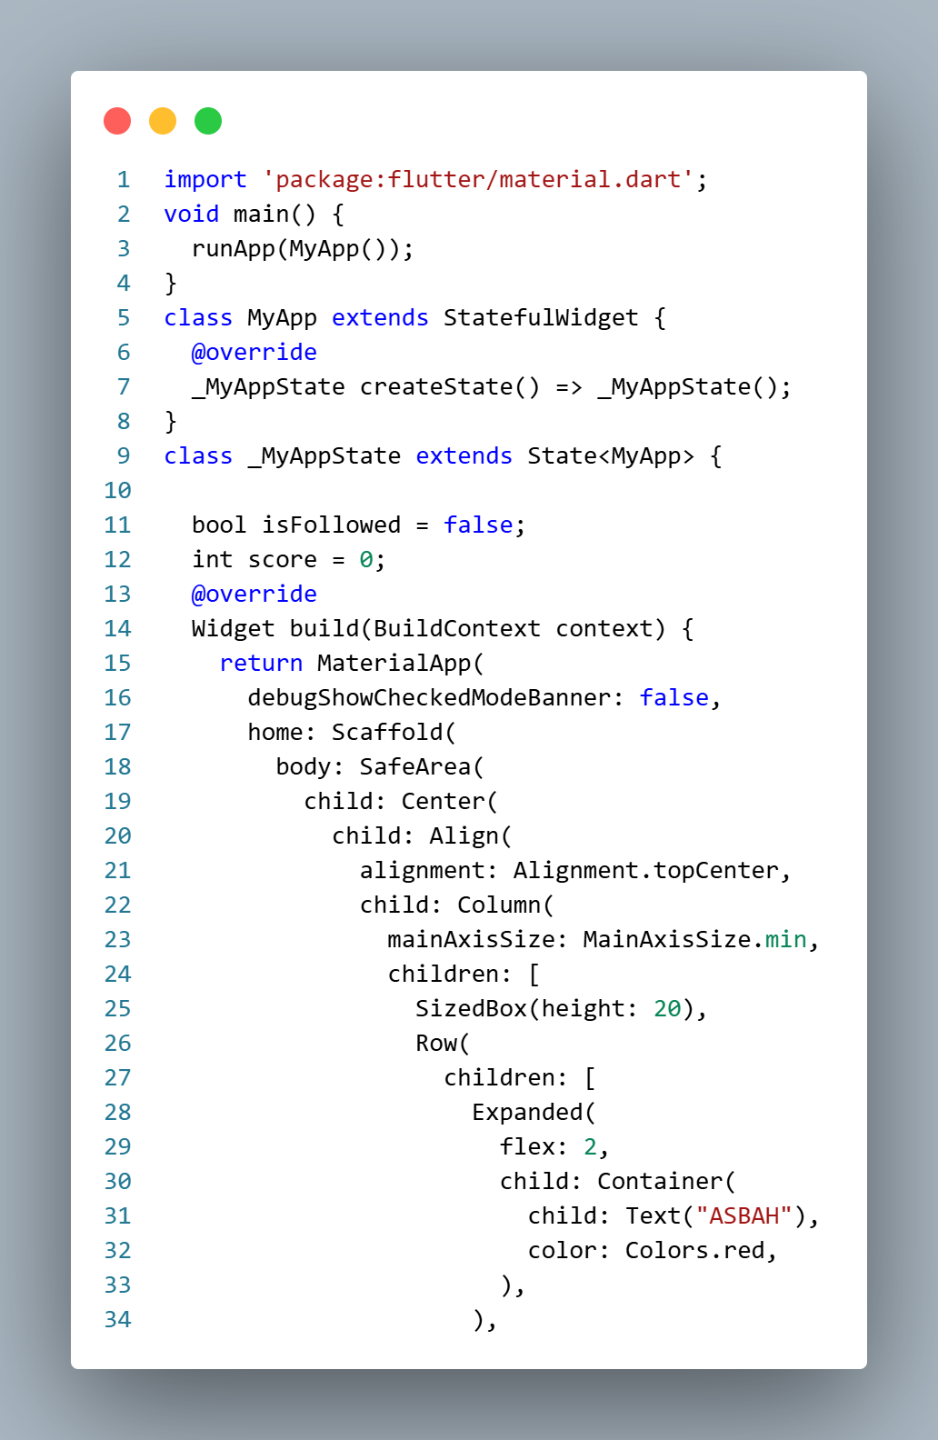

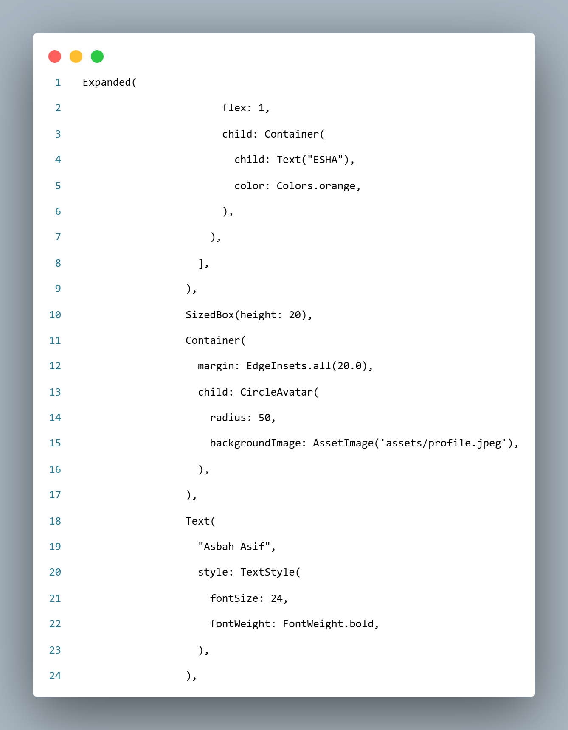

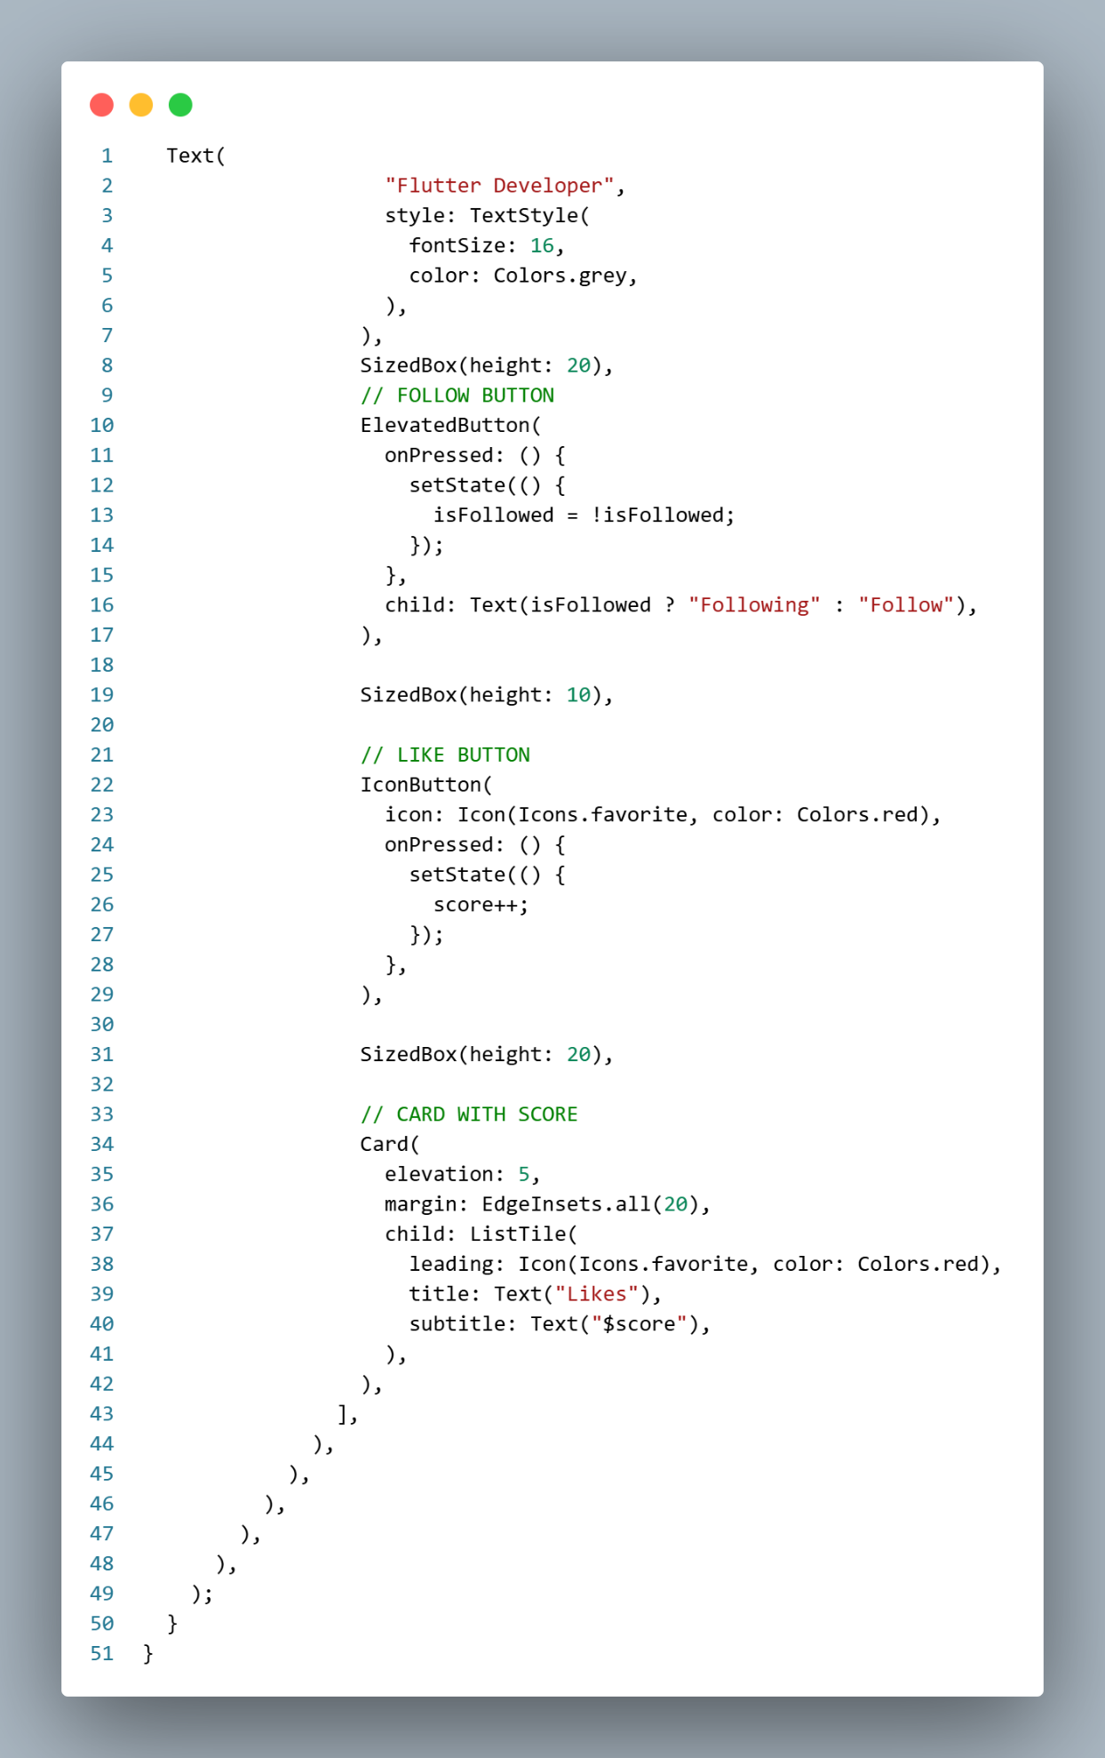
Output:
